

Please click [HERE](https://sunriseranch.secure.retreat.guru/program/paam-pam0423/?form=1&lang=en) for lodging for the Foundation in Anthroposophic N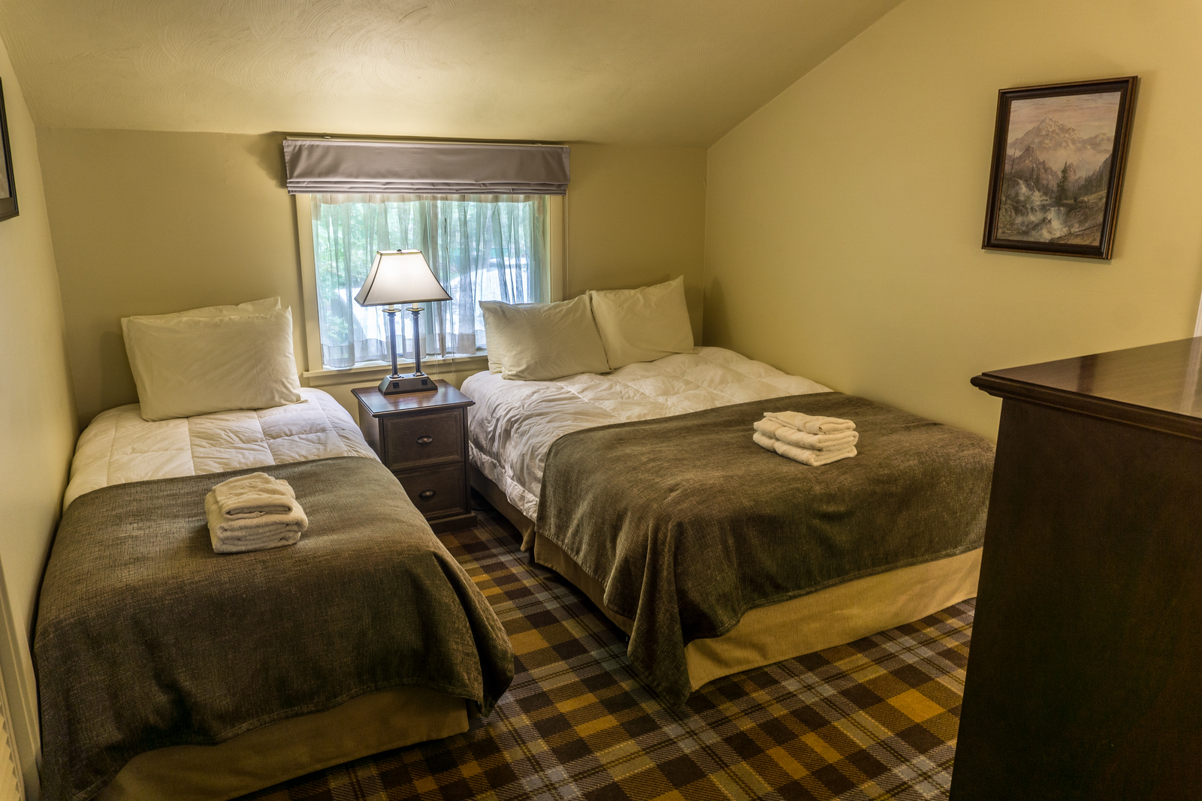ursing course.

For general information about Sunrise Ranch, please visit <https://sunriseranch.org/>